**PasswordVault**

CMSC 413 Intro to Cyber Security

Final Project

Jorge Zaquitzal

Pranaav Rao

Software Design

1.**Overview**:

The PasswordVault organizer is a Java built software with its own graphical user interface (GUI). As you can see the UML diagram is simple, however the power is in the encryption and decryption process. The encryption uses an 8-bit user key that the user creates and must maintain. It provides the simplest of usability with a very straightforward user interface. We factored out the bells and whistles of a generic program because a password organizer should be the simplest of programs to use. It requires an IDE that runs Java on any operating system Windows 8 or higher.

2.**System overview**:

The PasswordVault was designed with simplicity in mind. Using the robust Java encryption libraries, the PasswordVault simply takes in user input to either create, add, view, or delete contents of a password file then encrypts the entire file.

3.**Design Platform**:

This program was built using Eclipse Java IDE that was installed on a Windows 10 machine.

4. **Future Contingencies**:

It is possible the Java Libraries change so must the code when implementing encryption. Also upgrade encryption to AES for more security.

5.**Point of Contact**

School or Institution: Virginia Commonwealth University School of Engineering

Project Advisor: Carol Fung - cfung@vcu.edu

Student: Jorge Zaquitzal - zaquitzalja@vcu.edu

Student: Pranaav Rao - raop@vcu.edu

5.**Project References**

We used a multitude of references to learn the encryption and decryption process

Links:

<https://www.tutorialspoint.com/java_cryptography/java_cryptography_encrypting_data.htm>

<https://docs.oracle.com/javase/7/docs/api/javax/crypto/Cipher.html>

<https://docs.oracle.com/javase/8/docs/api/javax/crypto/spec/DESKeySpec.html>

<https://docs.oracle.com/javase/7/docs/api/javax/crypto/SecretKeyFactory.html>

<https://docs.oracle.com/cd/E17802_01/j2se/j2se/1.5.0/jcp/beta1/apidiffs/java/security/SecureRandom.html>

<https://docs.oracle.com/javase/tutorial/uiswing/>

6. **Detailed System Software Architecture**

The system is built using the Java programming language. It consists of a main class that creates the GUI ( graphical user interface) using the swing java libraries and the PasswordVault Class that implements the logic under the hood. Users enter options to create or add,view or delete to an existing file of contents which is then added to a unsecure password.txt that is stored in the directory of the application workspace. Once the user is done with the program , the entire file gets encrypted. Password.txt is then created into encrypted_password.txt that is saved to the same directory as before and password.txt is deleted. This system is designed to run on any OS that can support a Java IDE. Below is the UML diagram breaking down the PasswordValut Class.

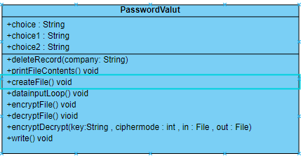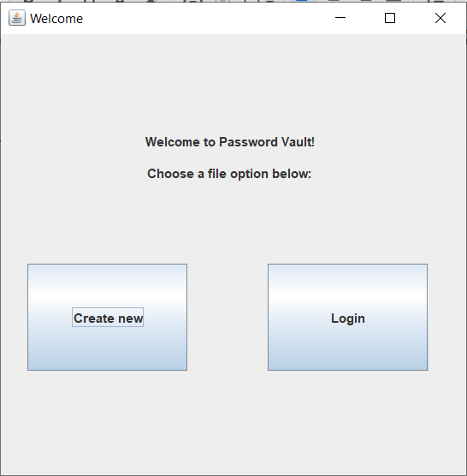

7.**Detailed components of encryption**

In this program we use the “ DES “ to encrypt and decrypt the password.txt file to then make it a secure_password.txt file. The DES algorithm is a symmetric key algorithm that is used to encrypt and decrypt electronic data. I use the same key for both processes. This is known as the block cipher. DES uses a block size of 64 bits and uses a key length of 56 bits. Link Java oracle site in references for additional information on methods within source code.

User Manual

Installation:

Download any IDE (integrated development environment) that supports Java.

For this project we used Eclipse and MS Visual Studio for Java

Download source code from:

<https://github.com/pranaavr/PasswordVault.git>

And download all the .Java files

Then all that is left is to run the Main class and you’re all set.

When the program is run, the GUI will be immediately visible displaying the Welcome page for this program.

Welcome



Click “Create new” if this is the first time using the program. Click “Login” if otherwise.

**NOTE: Clicking “Create new” if an existing password file exists will result in that file being overwritten and all previous information being lost :(

BRANCH: “Create new”

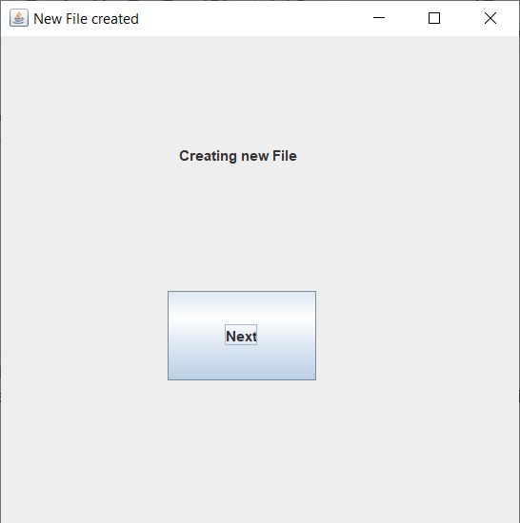

Congratulations! A new file has been created. This text file will store all the desired credentials for the PasswordVault program. Click “Next”

Add

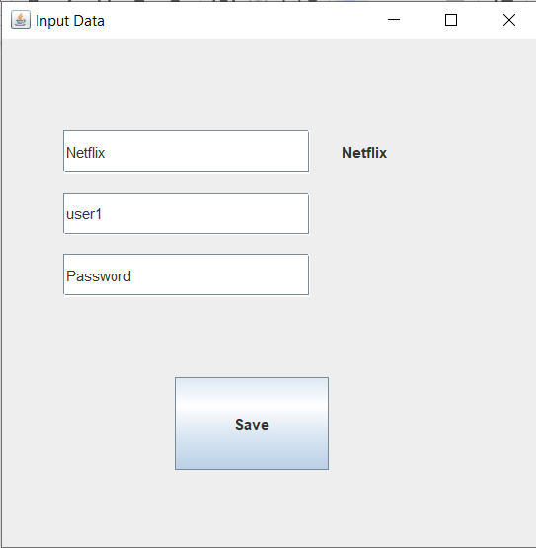

This is where the first record will be created to be stored securely in the PasswordVault! The first field is titled “Website” and acts as a label for which account login information is to be saved. The second field is the associated username and the third is the associated password. Delete existing field text and type in desired text.

IMPORTANT: Press ‘enter’ on keyboard to save input. If this is not done, no input will be saved

Click “Save” to continue to the Main page. Inputs will automatically be saved to data file

BRANCH: “Login”

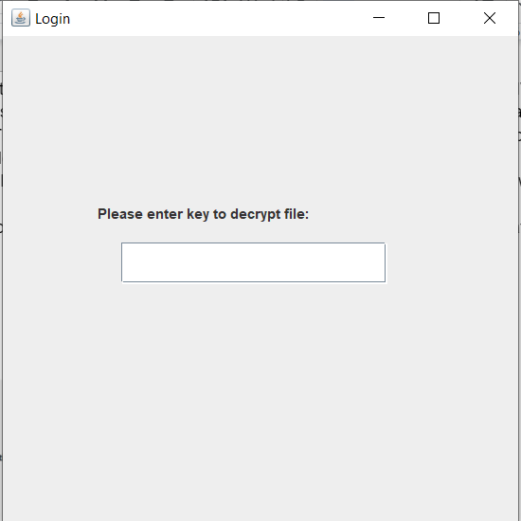

Enter previously created key exactly to re-enter the PasswordVault. Press ‘enter’ on keyboard to be taken to the Main page

Main

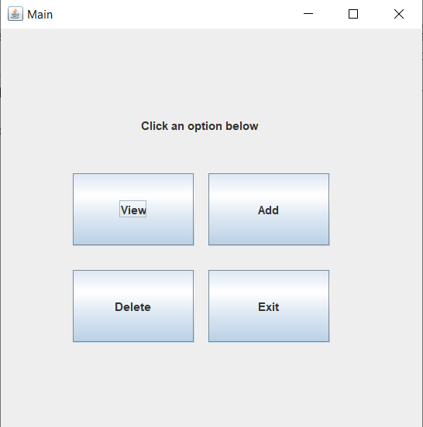

Here are all the options provided to manipulate the data stored in your PasswordVault. Click “View” to view listed credentials, “Add” to add more credentials, or “Delete” to delete an existing credential from the PasswordVault. Clicking “Exit” will open the “Create Key” window.

**NOTE: Scroll up to (BRANCH: “Create new”) to learn more about “Add”. More info on other options listed below

View

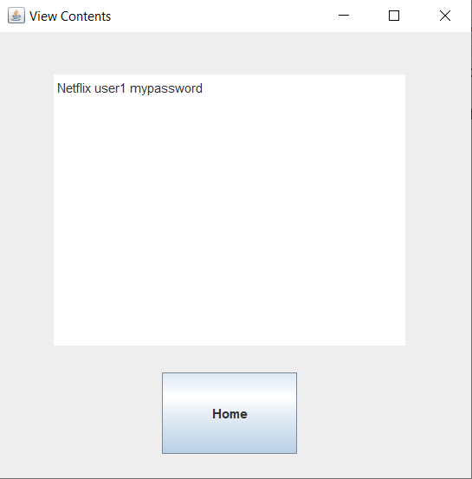

Here you can view the existing credentials in your PasswordVault. Click “Home” to return to the Options page.

Delete

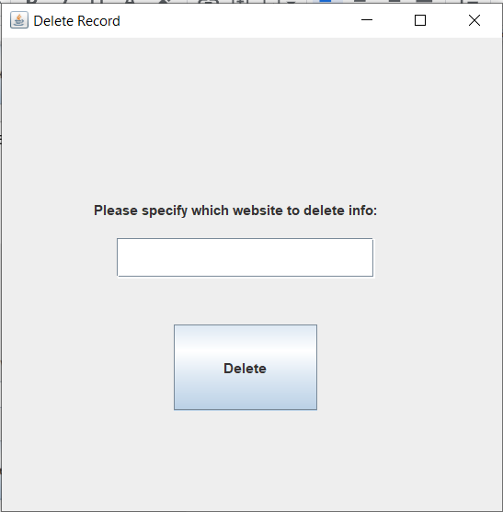

This page will give you the option to delete an existing record. It is based on the website or label of the record so exact input is required. Click “Delete ___” to delete the record which will then return to the Home page.

IMPORTANT: press ‘enter’ on keyboard after typing input into the field. This will result in the input printing on the button as shown below. This is how you know the data will be deleted.

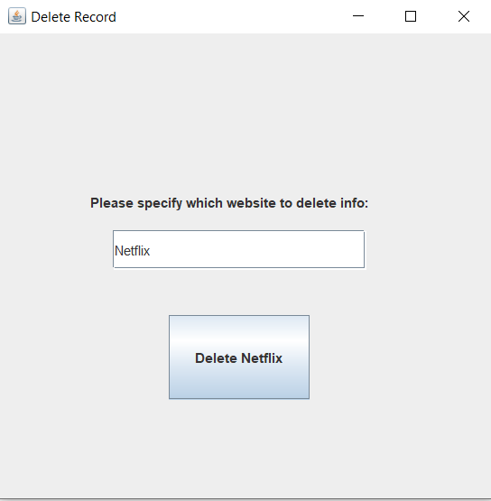

Create Key

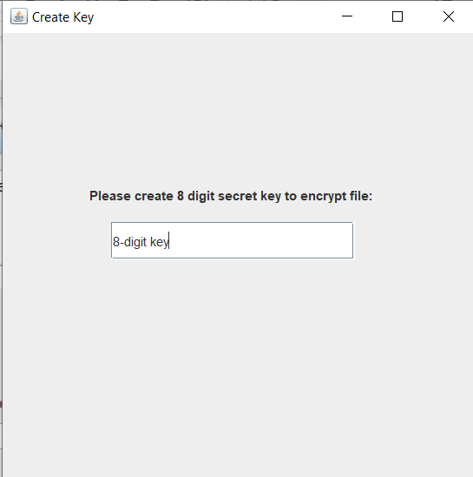

Before exiting the program, a key must be entered to validate access into the encrypted text file. An 8-digit key is recommended for security purposes. After choosing and typing the key, press ‘enter’ on the keyboard to exit and encrypt the text file.